*Survey Administered by*

**The Center for Technical Assistance for Excellence in Special Education (TAESE)**

**Utah State University**

**6896 Old Main Hill**

**Logan, UT 84322**

[**www.taese.org**](http://www.oklahomaparentscenter.org/)

***About the Survey***

**Parent Survey Brochure**

The Parent Survey is produced through a partnership between the Oklahoma State Department of Education - Special Education Services (OSDE-SES) and the Center for Technical Assistance for Excellence in Special Education (TAESE) at Utah State University.

The Parent Survey has only 14 questions and is easy to complete.

The **Parent Survey for Special Education** is for parents and caregivers of children from 3 years old and above who are currently (or recently) on an Individualized Education Program (IEP).

**County:**

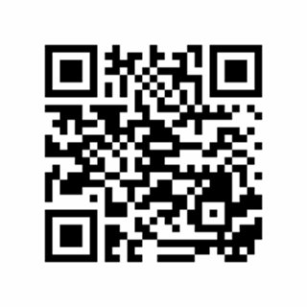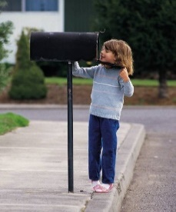

Use the link below or scan the QR code to complete the survey online.

**Survey Link:** https://survey.alchemer.com/s3/5140252/OKi8

One of the best ways to do this is to take the Parent Survey for Special Education each year. This survey asks for your opinions about the quality of support schools and IEP team members have provided you throughout the IEP process. We use this information to guide districts and the state toward improvement and to recognize areas of accomplishment. Without your opinions, we cannot identify districts’ areas of weakness and strength.

This Survey is for parents of students currently (or recently) on IEPs. Your responses will help guide efforts to improve services and results for students.

The Parent Survey for Special Education consists of 14 questions and should take only a few minutes to complete. Your responses are entirely anonymous. Your participation is voluntary, and you can stop the survey at any time.

The Parent Survey is a collaborative effort of the Oklahoma State Department of Education’s Special Education Services and the Center for Technical Assistance for Excellence in Special Education (TAESE) at Utah State University. The data is reported as a whole to districts and to the U.S. Department of Education.

Thank you for your time and effort to improve Oklahoma’s services to your children.

For more information, visit our website at:

<https://oklahoma.gov/education/services/special-education/parent-survey.html>

English/Spanish:

435-797-9009

To request a survey be mailed to you, email [Brenda.Smith@usu.edu](mailto:Brenda.Smith@usu.edu)

or call 435-797-9033

**Your opinions matter! Would you share yours with us?**

Answer the survey over the phone!

Take the survey online!

Complete the survey on paper!

Please call during office hours.

How can you take the survey?